Transport through membranes

Transport can be active or passive, where passive:
- Uses no energy
- The particles move randomly
- Goes with the concentration gradient
and active:
- Uses energy (mainly in the form of ATP)
- Particles move in the way they are forced
- Goes against the concentration gradient

There are 5 method of transport used inside cells:

Osmosis (Passive Transport) – The movement of water from a dilute to a concentrated area through a partially-permeable membrane (like a cell membrane).

Facilitated Diffusion (Passive Transport) – Channel proteins or carrier proteins let large or polar molecules and ions across the cell membrane.

Diffusion (Passive Transport) – The random movement of particles from a high concentration to a low concentration.
The molecules keep moving randomly forever, but at some point both areas are at equilibrium.

Pump Proteins (Active Transport) – Transport proteins that use energy to pump particles against the concentration gradient, e.g. the Na to K pump below.
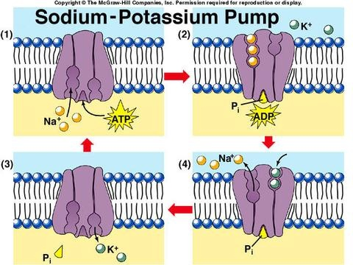
Endocytosis (Active Transport) – The cell forms a food vacuole around large particles by moving the membrane around it. This is used to take larger particles inside the cell, and how white blood cells engulf pathogens.

Exocytosis (Active Transport) – The cell forces large particles outside of the cell by fusing a vacuole containing the particle with the cell wall, then the vacuole changes shape to expel the particle. This is used when cells produce hormones, or when releasing waste.

